nuchaptersllc@gmail.com

[contact]

A Way to earn

Setting up your future for success. Being able to add an extra source of income.  
Being the driving force of all your investments

InVesting Guide

Building Your Own Future

The modern world is more connected now than at any other point in human history. Global markets and commercial trade largely influence our day to day lives. And in most cases shape how the world runs. So understanding these events and their operations is key to being a great investor.

An investor can be characterized or defined as a person who employs capital in markets now, to gain long term edge or profit in the future. And as you would expect there are many areas to employ cash or equivalents in the economy. You can invest in real estate, currencies, bonds, assets, and companies. In this guide we focus solely on investing in companies.

You may have heard that investing is difficult and hard to learn. Or you yourself may find markets or companies complicated to understand, but this course in 6 pages will be able to resolve those concerns. Our philosophy is that investing is simple if you learn a few principles but the way finance is taught is meant to confuse and dismiss anyone from learning it. Mostly, so you need these professionals. We believe the only thing that makes investing difficult, is what makes a good or bad investment is entirely based on the investor. For example if you bought stocks at $20 and a institution or large investors buy the same stock at $30 it would depend on your situation and the situation of the institution that would make the investment bad or good for both parties.

To make informed and well thought decisions investors must also have a goal for their investments. You never want to employ capital just on a whim. You must do diligent research on company’s financials, the industry, and the overall market. This course will teach you about each of these topics and learn where to get this information.

In this Guide we will cover the following concepts In depth:

* Ideology/ technical knowledge (bulls, bears, brokers, and Market theory)
* Indexes/exchanges (DOW Jones, S&P 500, Nasdaq)
* Overviewing the economy for opportunities
* Understanding Companies Fundamentals
* Reading Charts or graphs
* Intrinsic Value/Valuation principles
* Putting all the concepts together (video)

To be considered astute or a studied investor understanding basic economic concepts like supply, demand, and other market forces is key. In this guide we don’t go over the basics of economics but an important idea is auction market theory.

Auction market theory: States that financial markets are no different than any other market in the world. The job of buyers and sellers in the market is to find the fair value of a business or other securities. Buyers bid on the value they think it’s worth and sellers either accept or reject that price.

Bid price: Is the highest price a buyer will buy the stock or security

Ask price: Is the lowest price a seller will sell the stock or security

Spread: The spread is the difference between the bid and ask price

A stockbroker is an individual or institution whose job is to buy and sell stocks for a market participant. The broker connects an investor to the exchange. Examples of brokers would be, Fidelity, Charles Schwab, Robinhood, Webull, Etc. The 3 main types of orders that can be submitted are Market, Limit, and stop orders.

Market orders: Buying a stock at whatever price it is listed right now.

Limit orders: Tells your broker to buy a stock when the price goes lower than the current price.

Stop orders: Tells your broker you want to buy a stock when it goes up to a certain price.

To understand investing you must understand the mind of an investor. Investor ideology can really be broken down into 2 groups the bulls and the bears:

Bull Mindset: Is believing the market, Stock, or other securities are going to increase in value.

Bear Mindset: Is believing the market, Stock, or other securities are going to decrease in value based on astute research.

Long investing is when an investor buys the market or a specific security/stock because they believe it to be fairly priced or because they believe it will trend upward in value. Bulls usually tend to take long positions. Short investing is when an investor borrows shares of a specific security/stock from their broker because they believe the price will decline and sell them at a lower price. Bears usually tend to take short positions.

Some of the most important decisions made in investing require having a base knowledge of indexes and exchanges and having a realistic economic outlook.

Stock market index: Is an index that shows the performance of the overall stock market or specific areas of it. Understanding indexes and what they measure really narrows down what you are looking for in markets.

Stock exchanges: Are a marketplace where stockbrokers and traders buy and sell securities such as bonds or stock/shares. Examples of exchanges would be the (NYSE New York Stock exchange) or the Nasdaq.

An example of indexes would be the DOW or S&P 500. The Dow is an index listing 30 of largest businesses in the U.S. And the S&P 500 lists the top 500 profitable businesses listed on U.S. stock exchanges. These indexes can be useful for constructing an economic outlook of the entire market and maybe what to expect in the future. Having an economic outlook is essential to make savvy decisions. Knowing if the economy is entering a recession, knowing low volume trading sessions of the market, or keeping up on the latest news can affect the way you have to invest to keep your risk low. They also can reveal unique opportunities to buy and sell like during times of uncertainty or mass panic.

The most important part of investing is understanding most companies’ fundamentals. The more information you can gather about the company through its financials/fundamentals the better your return will be. There are many sources of information investors can use that the companies themselves release to the public. For example, some investors listen to earnings calls and investor meetings, or read the company’s annual reports. In this guide we focus primarily on understanding the financial statements. A company’s financial statements consist of the balance sheet, income statement, and the Cash flow statement.

The Balance Sheet – Is a company’s record of what it owns contrasted by what it owes (Like a net worth calculation for companies). A company’s assets should always equal its liabilities.

Income Statement – Is a company’s record of how much money the business made in revenue and lost in expenses to calculate net income.

Cash-flow Statement – Is a company’s record of how money is moving through the business. Like when it comes in and where it goes when it leaves out.

Studying long term trends of the market can be integral to making great investments. Knowing where price has been before may tip you off to where it’s going next.

Reading charts is about knowing how price has moved in the past up to the present moment. How most investors or traders do this is by looking at trend. Markets usually trend different from one another, but they all have a few characteristics that can be identified.

Ways that Markets/Stocks Trend

-Uptrend

* When a market trend is making **higher highs** and *higher lows* the market is trending upward.

-Downtrend

* When a market trend is making **lower highs** and *lower lows* the market is trending downward.

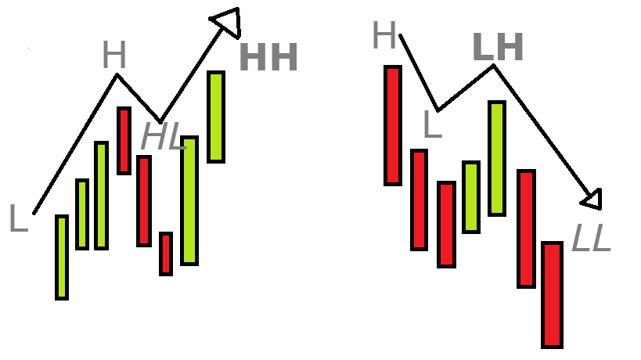

Highs – Are places in the market where trend crests. Lows - Are places in the market where trend troughs.

Keep in mind a market in an uptrend is considered trending up, until price goes below its lowest low that turns it into a downtrend. And in a down trending market its always considered to be trending down, until price goes above its highest high.

To read markets effectively you also must be able to know how sessions or trading volume is organized. Most charting platforms organize session data into candlesticks.

-Candlesticks

Candlestick data represents the changes in price over the specified time period. (You change the timeframe on whatever charting platform you’re using)

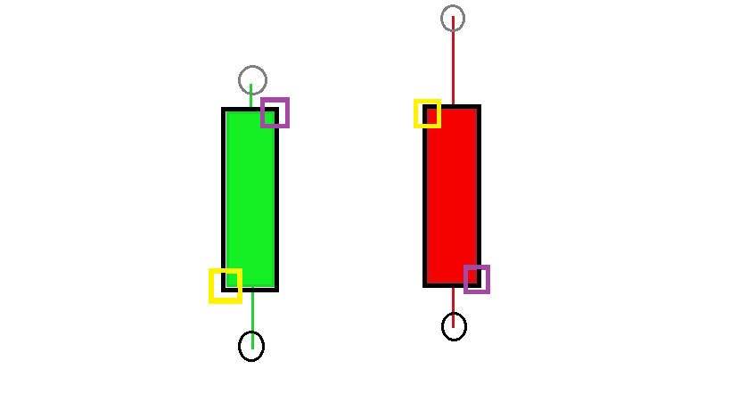

High: Is the highest price during the session

Open: Is the price the session starts out at.

Close: Is the price the session closes at.

Low: Is the lowest point during the session.